**CAP 6619 Deep Learning**

**2019 Fall**

Homework 1 [12 Pts, Due: Sept 7 2019. Late Penalty: -2/day]

[If two homework submissions are found to be similar to each other, both submissions will receive 0 grade]

[Homework solutions must be submitted through Canvas. No email submission is accepted. If you have multiple files, please include all files as one zip file, and submit zip file online (only zip, pdf, or word files are allowed). You can always update your submissions. Only the latest version will be graded.]

**Question 1 [2 pts: 0.4/each]:** Use your own language to briefly explain following concepts:

1. Machine learning:
2. Machine learning models:
3. Neural Network:
4. Summary key difference between Rule-based systems, Classic machine learing, and Deep learning:
5. Artificial Neuron

**Question 2 [1.5 pts]** Please show the perceptron structure and explain the function of each component [0.5 pt]. What is the purpose of using training examples in a neural network [0.5 pt]? Given proper weight values, what is expected output vs. actual output of an example? [0.5 pt]

**Question 3 [1.5 pts]** Figure 1 shows a set of samples (dots) which are labeled as red and green (red dots belong to class C2, and green dots belong to class C1). Explain how can we train a neuron to correctly classify dots into different classes (C1 vs. C2) [0.5 pt], What are the roles of the weight values of the neuron [0.5 pt], Show the decision boundary of the learned neuron [0.5 pt]

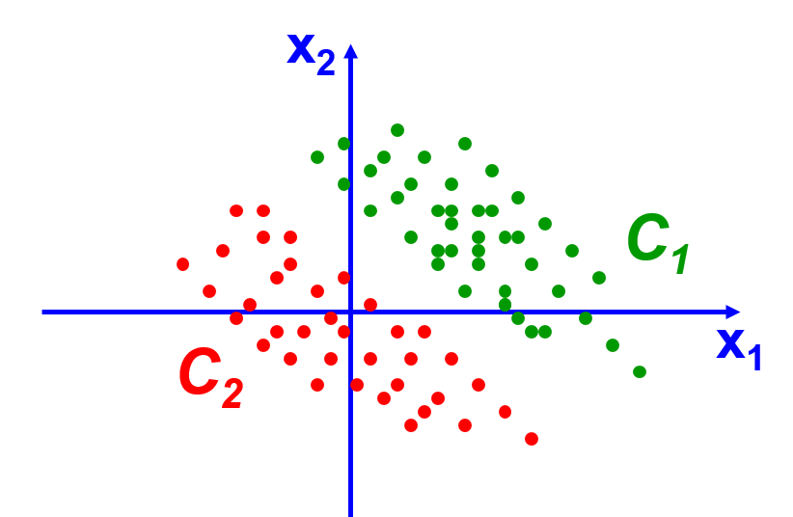

Figure 1

**Question 4 [1 pt]** What is a Perceptron Learning Rule? [0.5 pt] Please use your own language, explain how perceptron learning rule updates/learns weight values for the network [0.5 pt]

**Question 5 [2 pts]** Assuming we have two sets of instances, which belong to two classes, with each class containing three instances. C1={(1, 0), (1, 1), (0, -1)}; C2={(0, 1), (-1, 0), (-1, -1)}. The class label of C1 is 1, and the class label of C2 is 0. Assuming η=1, and the initial weights are *w0*=1, *w1*=1, and *w2*=1. Please use perceptron learning rule to learn a linear decision surface for these two classes. List the results in the first two rounds by using tables in the following form.

Assume the activation is defined as follow.



|  |  |  |  |  |  |  |
| --- | --- | --- | --- | --- | --- | --- |
| **Input** | **Weight** | **v** | **Desired** | **Actual** | **Update?** | **New Weight** |
| **(1,1,0)** |  |  |  |  |  |  |
| **(1,1,1)** |  |  |  |  |  |  |
| **(1,0,-1)** |  |  |  |  |  |  |
| **(1,0,1)** |  |  |  |  |  |  |
| **(1,-1,0)** |  |  |  |  |  |  |
| **(1,-1,-1)** |  |  |  |  |  |  |

The Second Pass

|  |  |  |  |  |  |  |
| --- | --- | --- | --- | --- | --- | --- |
| **Input** | **Weight** | **v** | **Desired** | **Actual** | **Update?** | **New Weight** |
| **(1,1,0)** |  |  |  |  |  |  |
| **(1,1,1)** |  |  |  |  |  |  |
| **(1,0,-1)** |  |  |  |  |  |  |
| **(1,0,1)** |  |  |  |  |  |  |
| **(1,-1,0)**  **(1,-1,-1)** |  |  |  |  |  |  |

For all programming tasks, please submit the RNotebook (or Markdown) as html files for grading (please make sure that your HTML file contains both R scripts and results).

Students can use other programming language, such as Python, to implement the task, conditioned by that the home submissions must address all task requirements.

**Question 6 [2 pts]:** Please download and install R or Rstudio, and implement following programming tasks:

* Please create a vector with twenty random values [0.25 pt]
* Please use the vector to create a 4x5 matrix [0.25 pt]
* Please create a data.frame from the 4x5 matrix, and change the column names of the data frame as “fea1”, “fea2”, “fea3”, “fea4”, “fea5” [0.25 pt]
* Please create a function to find the row number with the large row-sum (the function will take a data.frame as input, calculate the sum of each row, and return the row number with the largest sum and also return the sum) [0.25 pt]
* Please use lapply, sapply, or apply to find mean value of each row and each column, respectively. [0.5 pt]
* Please create a new data.frame (A) using all rows and “fea1” and “fea3” from the above data.frame, and create a new data.frame (B) using all rows and “fea2” and “fea4” from the above data.frame [0.25 pt]
* Please calculate the multiplication of matrix A and the transpose of matrix B. [0.25 pt]

**Question 7 [2 pts]:** Please download housing.header.txt dataset from Canvas, and use R to implement tasks below (a brief description of this dataset is available from the following URL)

<https://archive.ics.uci.edu/ml/datasets/housing>

* Report all samples with respect to the Crim index on a plot (the x-axis show the index of the sample, and the y-axis shows the Crim index of the sample) [0.25 pt]
* Show both histogram of the Crim index and the density of the Crim index on a 1x2 frame. [0.25 pt]
* Show following four scatter plots in one frame (1x4), crim vs. medv, Rm vs. medv, Age vs. medv, Tax vs. medv, and explain how are they (Crim, Rm, Age, Tax) correlated to the medium house value (Medv) [0.25 pt]
* Report pairwise correlation between every two variables (either as a matrix or as a level plot) [0.25 pt]
* Please explain which variable is mostly positively correlated to Medv (medium house value), and which variable is mostly negatively correlated to Medv. [0.25 pt]
* Draw scatterplots to show relationship between each attribute and Medv, respectively. [0.25 pt]
* Explain how to use scatterplots to find attributes which are positively correlated to Medv, negatively correlated to Medv, or independent of Medv, respectively [0.25 pt], and validate your observations using pairwise correlation values [0.25 pt].